**Task1**

**Docker Commands**

docker images

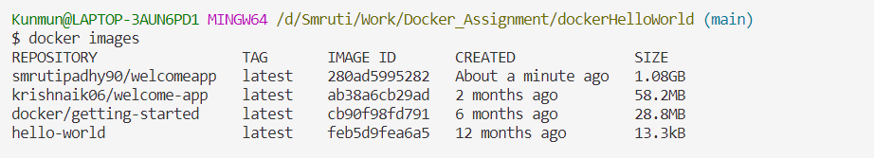

docker pull

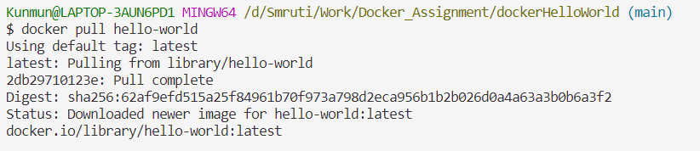

docker - - version



docker run



docker ps



docker build

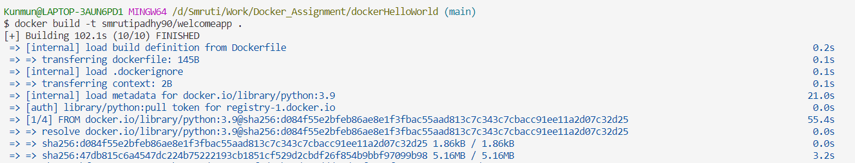

docker start



docker stop



docker rmi (delete image)

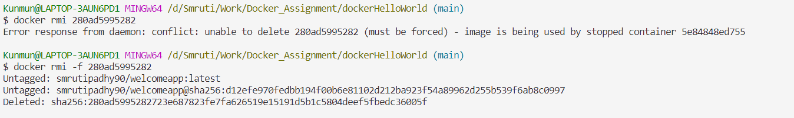

docker push

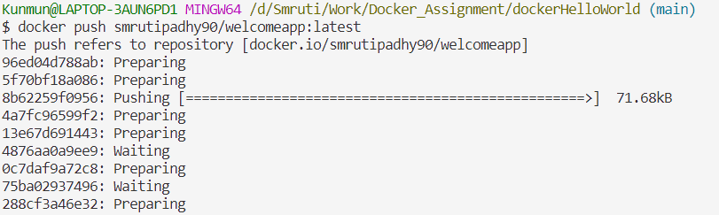

docker history

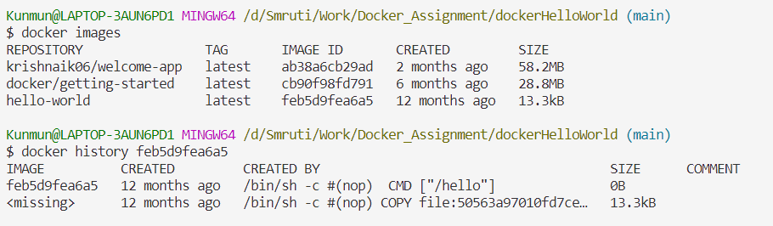

docker search <text>

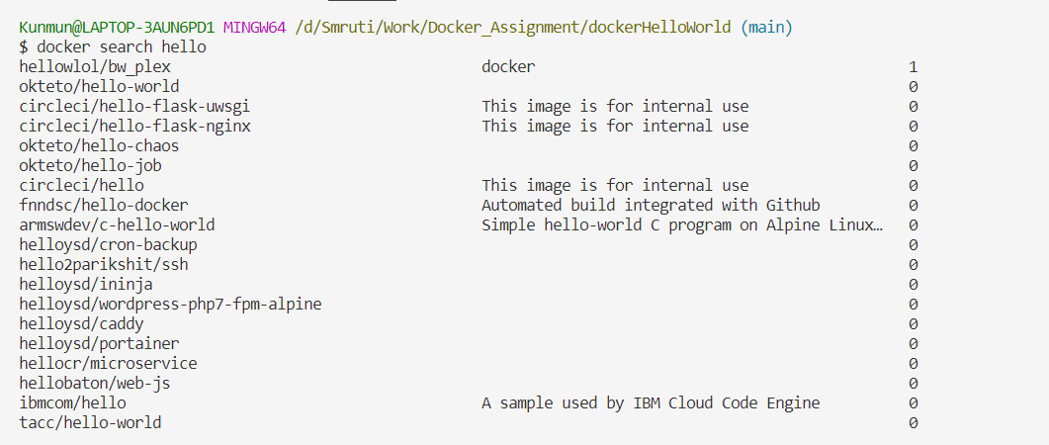

docker load

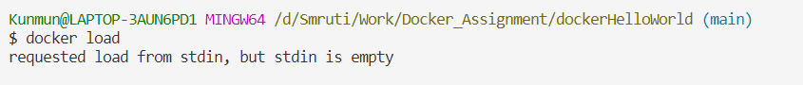

docker logs

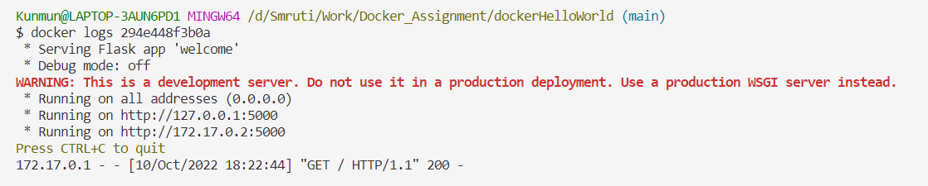

docker system prune

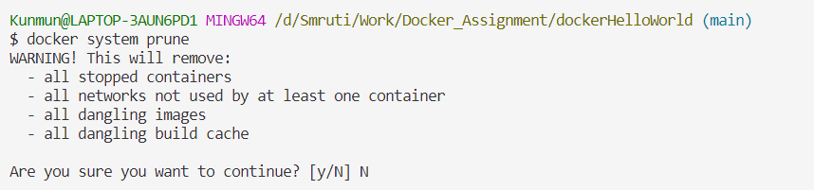

Docker volume ls

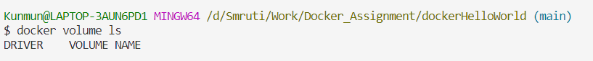

docker exec -it <containerid>

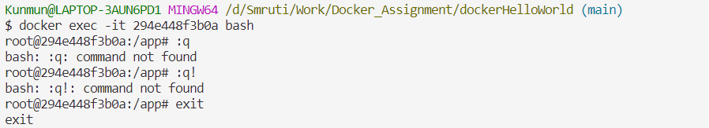

docker inspect

